1. Add docker support to the project we have:  
   Right click the project name, then:  
   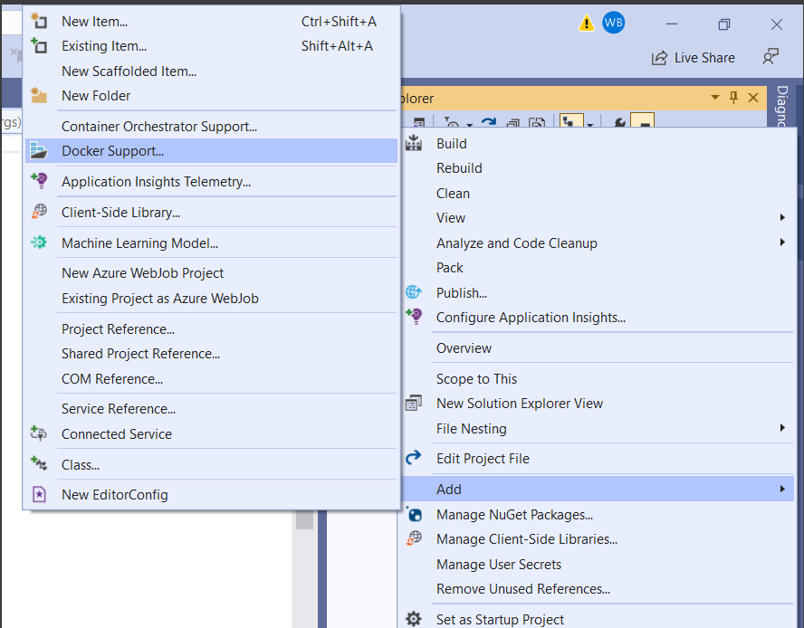  
     
   choose the container type:  
   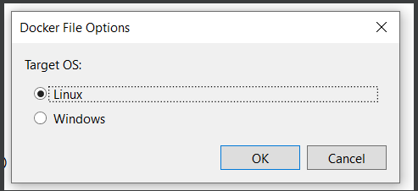
2. Basically this will add a Dockerfile to the project, and add Docker settings for launching the project withing visual studio development mode:  
     
   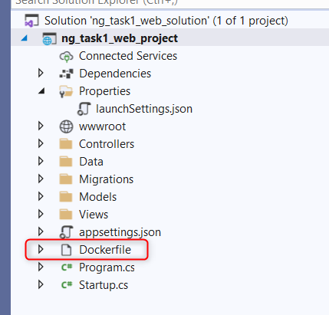  
   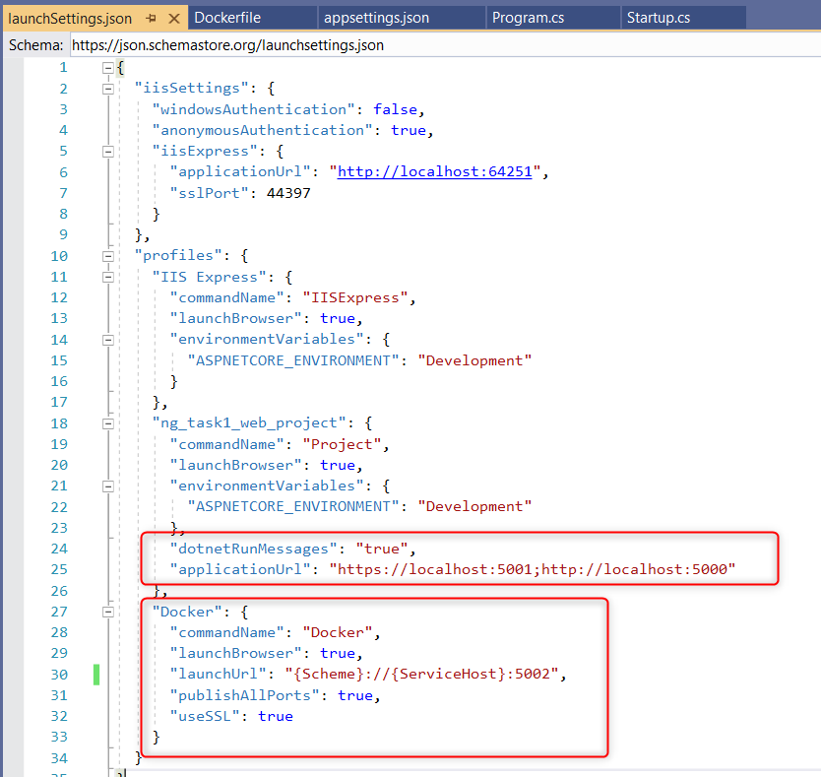
3. In a production environment, switch the application before build to production mode, and do not keep it in development mode because the application will display error/exception messages with a lot of details in case of problems. Also https support should be added. Anyway, I will skip those for now.
4. Please continue the steps from the text file.